HW1:
請描述以下程式碼在C++與JAVA中執行的結果(無視語法錯誤)
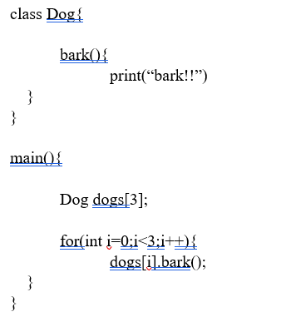
Ans:
C++ :
bark!!
bark!!
bark!!

Java :
Runtime error (NullPointerException)
the array only stores references initialized to null, so calling a method results in a NullPointerException.

HW2:
If I want to swap two variables in Java, how should I do it?
Please write some Java code to show your answer.
Ans:
public class Main {
public static void main(String[] args) {
int a = 5;
int b = 10;
int temp = a;
a = b;
b = temp;
System.out.println("a = " + a);
System.out.println("b = " + b);
}
}

